Practical 7 — PHP Form Processing and CSV/JSON File Storage

Aim
To process the registration form on the server with PHP and persist valid submissions to file storage with validation and duplicate handling.

Theory
Server processing is authoritative: the browser can be bypassed, so PHP re-validates every field, rejects duplicates, appends to storage, and returns a success or error page. File storage suits small deployments before a database is introduced.
- The handler at practical-7/php/register.php (about 13 KB) mirrors the browser rules on the server and never trusts client input.
- Valid registrations are appended to file storage while the data folder is protected against direct listing and script execution.
- Duplicate emails are rejected with a friendly message and no second record is written. • Invalid submissions return the user to correct fields rather than silently dropping data.
- This is the first practical requiring a PHP runtime; static hosting alone cannot execute it.

Procedure
6. Pointed the registration form at the PHP handler and kept browser validation as a first pass. 1. Implemented server-side validation, duplicate detection and file append with locked writes.
- Protected the data folder against browsing and execution.
- Inspected the handler and storage layout on disk; PHP was not installed on this machine so live execution was not re-run here.
- Recorded the execution gap as a placeholder rather than claiming an unrun result.
ITUE203 Web Development Framework

Screenshots

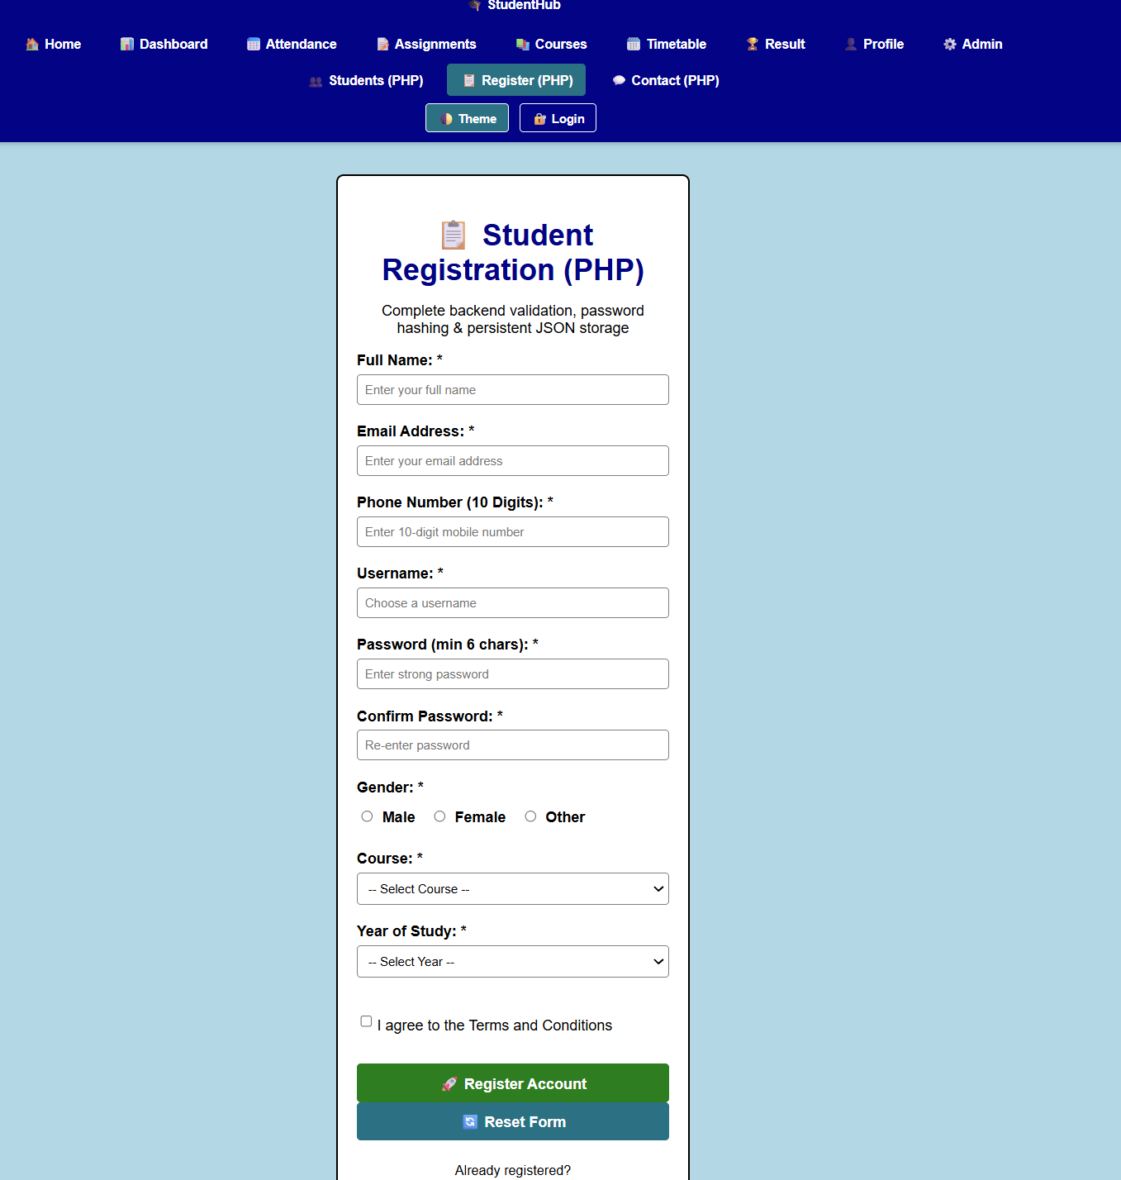

GitHub Repository Link
Practical repository : https://github.com/Rkpatel34/StudentHub/tree/main/studenthub

Conclusion
Practical 7 moved trust to the server and established durable storage, preparing the migration to MySQL next.

